SENSITIVITY ANALYSIS ASSIGNMENT

Name: V.Sai kumar

Reg.no: 22235

Question B)

Outdoors, Inc has, as one of its product lines, lawn furniture. They currently have three items in that line: a lawn chair, a standard bench, and a table. These products are produced in a two-step manufacturing process involving the tube-bending department and the welding department. The time required by each item in each department is as follows:

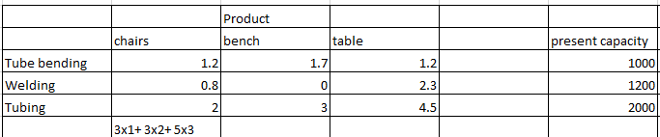

The contribution that Outdoors, Inc. receives from the manufacture and sale of one unit of each product is $3 for a lawn chair, $3 for a bench and $5 for a table. The company is trying to plan its production mix for the current selling season. It feels that it can sell any number it produces, but unfortunately production is further limited by available material, because of a prolonged strike. The company has on hand 2000 lbs. of tubing. The three products require the following amounts of this tubing: 2 lbs. per chair, 3 lbs. per bench, and 4.5 lbs. per table.

Question and Answers:

1. Formulate LP model for this problem?

Number of Lawn Chairs = x1,

Number of Benches = x2,

Number of Tables = x3.

Objective function,

Maximize Z = 3x1 + 3x2 + 5x3

Subject to:

1.2x1 + 1.7x2 + 1.2x3 <= 1000 (M1)

0.8x1 + 0x2 + 2.3x3 <= 1200(M2)

2x1 + 3x2 + 4.5x3 <= 2000(M3)

X1, x2, x3 >= 0

1. Solve the problem by SOLVER?

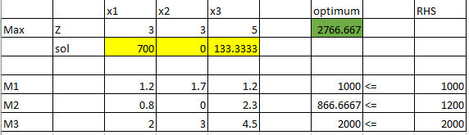

Solution: Z = 2766.667,

x1 = 700,

x2 = 0, x3 = 133.3333

The Maximum Profit it can make is 2766.667 $ by selling 700 Lawn Chairs ,0 Benches, 133 Tables under given constraints.

1. What is the optimal production mix? What contribution can the firm anticipate by producing this mix?

From the obtained solution , the optimal production mix is 700 Lawn Chairs, 0 Benches 133 Tables and Profit that can be made is 2766.667.

The firm need not produce or spend money or materials for manufacturing the Benches since the optimum profit is made by not selling any benches.

1. What is the value of one unit more of tube-bending time? Of welding time? Of metal tubing?

A) 1 more unit of Tube-Bending Time:

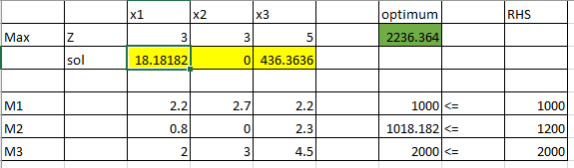

If there is increase in one more unit of Tube Bedding time the profit gained is 2236.364 $ By selling 18 chairs and 0 benches and 436 tables.

B) 1 more unit of Welding Time:

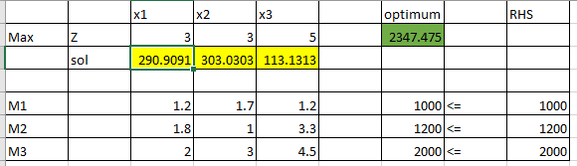

C) 1 more unit of Metal Tubing Time:

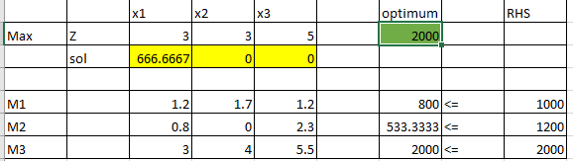

1. A local distributor has offered to sell Outdoors, Inc some additional metal tubing for $ 0.60/lb. Should Outdoors buy it? If yes, how much would the firm’s contribution increase if they bought 500 lbs. and used it in an optimal fashion?

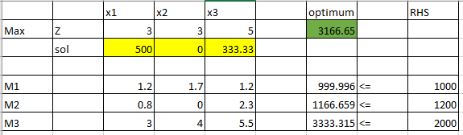

So, the cost for 500 lbs. of metal tubing is 300 $. Profit made = 3166.667$ - 300$ = 2866.667$. Before we were making 2766.667$ without these 500 lbs. of metal tubing. Now we are making 100$ more than the earlier time. So, it’s advisable

1. If Outdoors, Inc. feels that it must produce at least 100 benches to round out its product line, what effect will that have on its contribution?

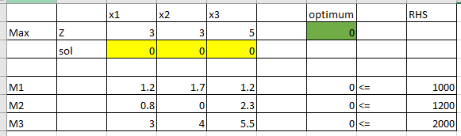

1. The R&D department has been redesigning the bench to make it more profitable. The new design will require 1.1 hours of tube-bending time, 2.0 hours of welding time, and 2.0 lbs. of metal tubing. If it can sell one unit of this bench with a unit contributing of $3, what effect will it have on overall contribution?

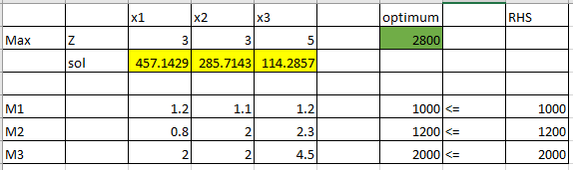

If the R&D decides the given changes for manufacturing benches, the optimum value is 2800$. The objective function remains the same, since the product price was decided for 3$. Here, 457 lawn chairs, 285 benches and 114 tables are getting manufactured and the profit increased is 33.33$. So, it’s advisable.

1. Outdoors, Inc. has a chance to sell some of its capacity in tube bending at cost + $1.50 per hour. If it sells 200 hours at that price, how will this affect contribution?

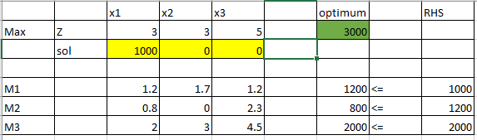

we will be investing $1.50 per hour to increase the tube-bending time. To increase time, we should spend $1.50\*200 = 300$. So, our total tube bending time will be 1200 hours

1. If the contribution on chairs were to decrease to $2.50, what would be the optimal production mix and what contribution would this production plan give?

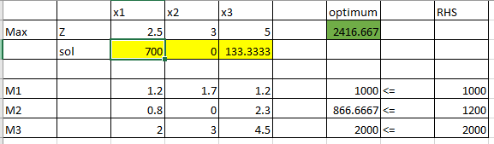

Profit obtained is 2416.667 $ and products manufactured are 700 lawn chairs, 0 benches and 133 tables.

Since the profit got decreased from 2766.667$ to 2416.667 i.e. (-350$). So, Outdoors Inc. will give 350$ less profit in this production plan!